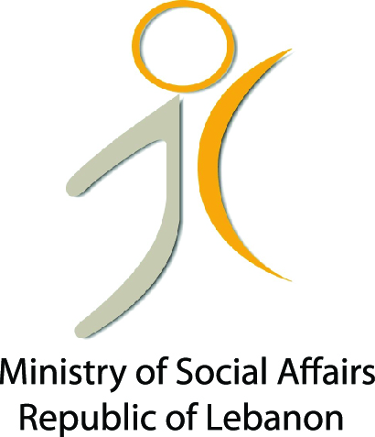
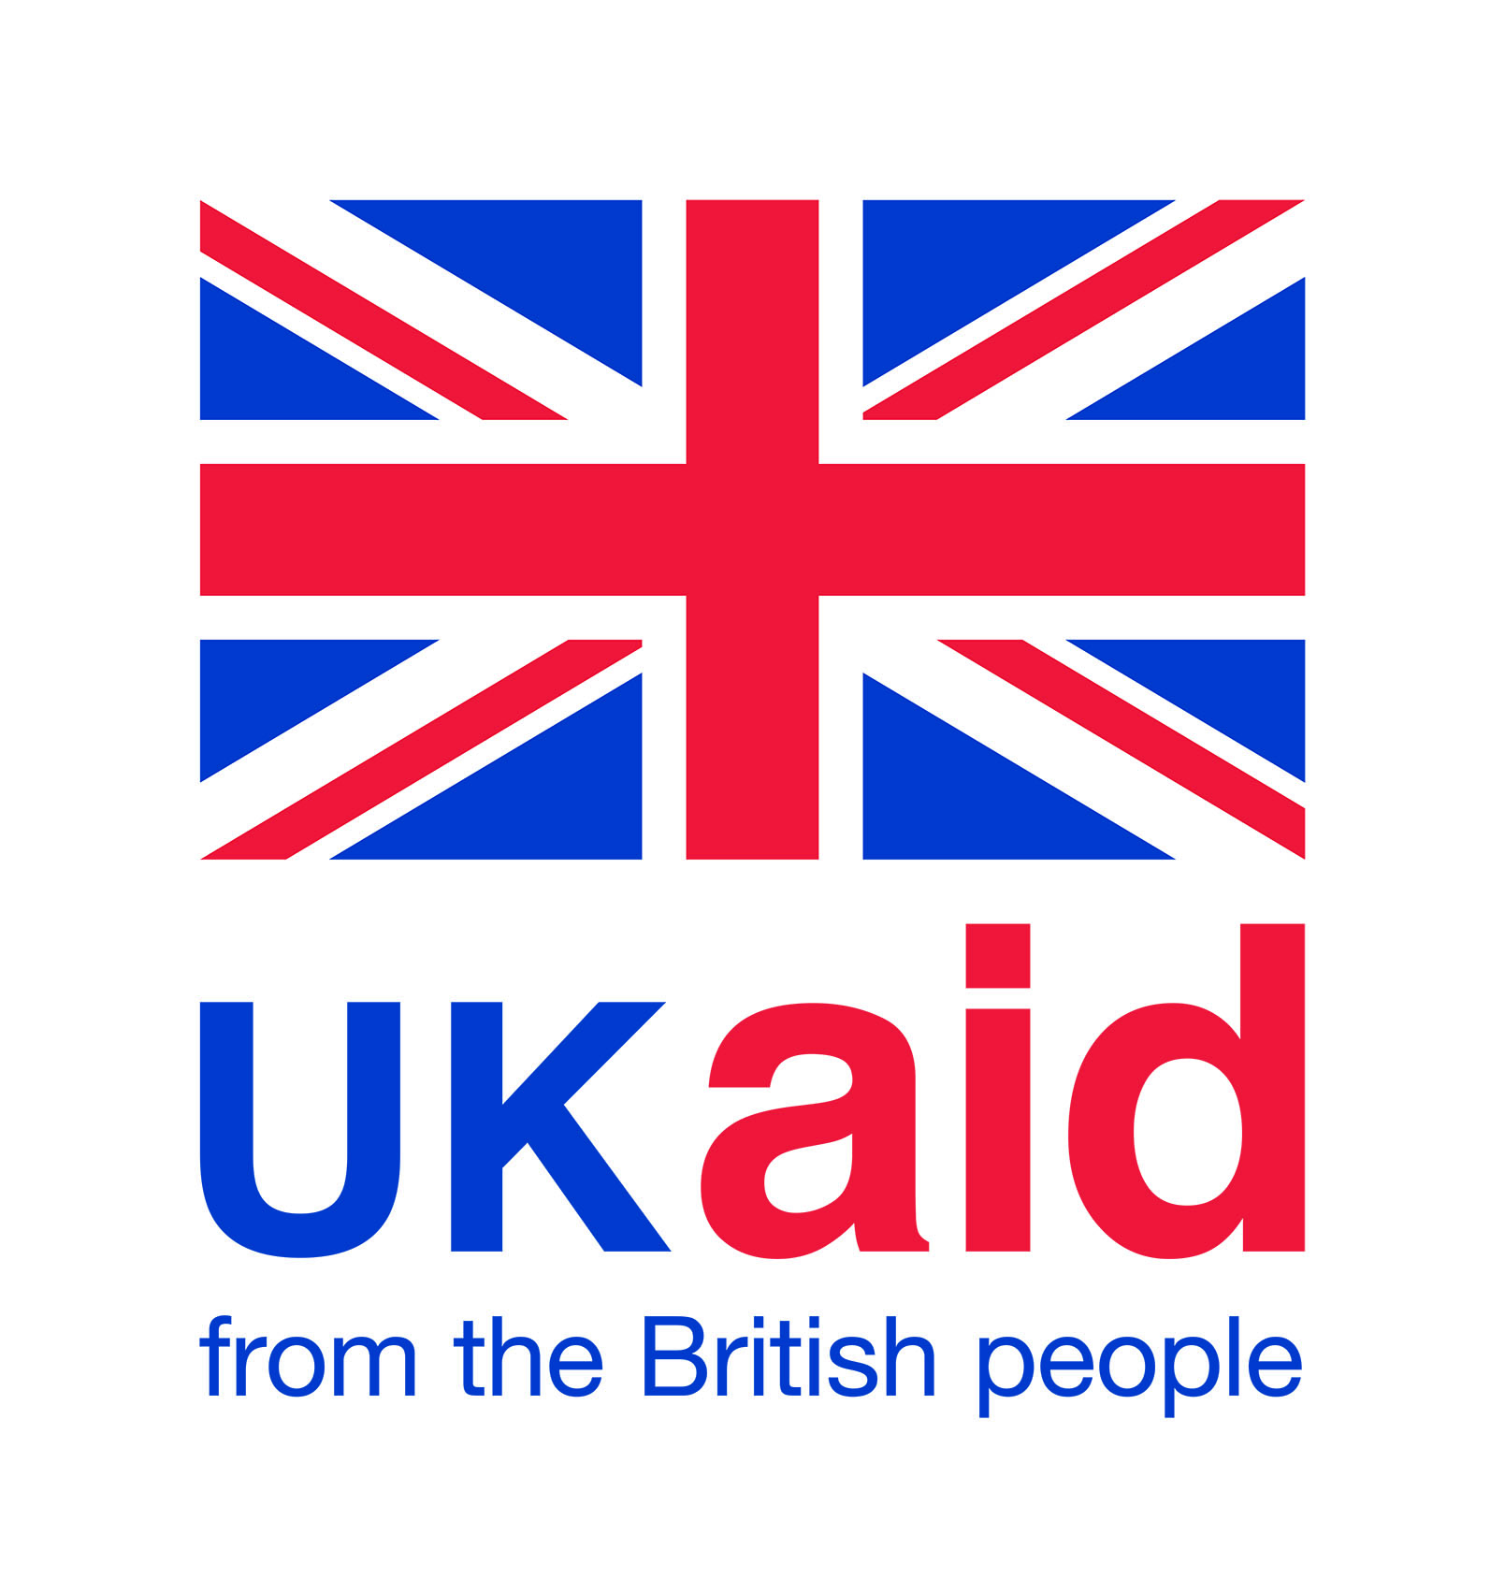
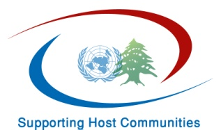

Quarterly Progress Report Number 1
Period:

Summary Table
Executing Agency:

Country:

Project:

Project Duration:

Total Funds Allocated:

Reporting Period:

Contact Person:

Project Background:

Implementation Progress:
Two main activities under Social Cohesion component were implemented:
- The “Conflict Mapping/Analysis “and
- “Crisis and Conflict Management”

- For the Conflict Mapping/Conflict Analysis activity:
- Terms of Reference (TOR) for the conflict mapping/conflict analysis have been developed and finalized
- Suitable partners for this activity were identified through a consultation process
- Following several meetings, an agreement was reached with “Lebanon Support”, a Lebanese and independent non-governmental organization that aims at enhancing the knowledge base of civil society actors and development, recovery and emergency actors. The final project’s proposal was also developed and approved by both parties
- The agreement was signed with Lebanon Support and the final methodology which includes the indicators for the conflict mapping and the methodology for the conflict analysis has been developed and approved through a consultation process with key experts.

- Crisis and Conflict Management activities:
- Introductory meetings and initial contact were finalized with all targeted groups in the three different areas during which the intervention and its objectives has been presented to the target groups and its methodology validated. The representatives of these different municipalities showed a great interest in taking part in this activity and stressed on its importance. The targeted municipalities are:
- Wadi Khaled cluster including the following villages: Wadi Khaled, Amayer, Bani Sakher, Hichi, Rama, Mqaibleh, el Fard, Khat el Petrol
- Zahle cluster including the following villages: Bar Elias, Majdel Anjar, Taalabaya, Saadnayel, Terboul
- South including the following villages: Sarafand, Baysariyyeh, Ghazzieh, Bourj Chemali, Cheb’a, Khiyam, Hebbariyyeh

- Procurement of a facilitator / trainer to provide facilitation and additional capacity building support to establish local peace building mechanism and come up with the Social Cohesion Strategy for Wadi Khaled cluster was finalized

- Advanced meetings with Wadi Khaled cluster were held and identification of the local actors (including the municipalities’ members but also other prominent figures from the different villages) has been made. During these meetings, it was agreed that a follow up on the recommendations developed during the 2013 training programme implemented by UNDP should be the main focus of the upcoming process support for peace building in Wadi Khaled and the basis for the development of the Social Cohesion Strategy for the area.

Implementation Arrangements:

- Relationship / coordination with Ministry of Social Affairs
- Relationship with DFID/UK to serve the host communities
- Organigram outlining the project team structure

Challenges:
- The security situation which makes it sometimes hard to get to the field
- The pressure the municipalities are facing from all parties and organizations and their tight schedules

Lessons Learned:

Nothing major to date

Financial Status:

- Actual expenditures as of to date.

- Commitments for next tranche.

Reporting on Results and Impact:
Outcome | Outcome Indicators | Target | Progress | Pending Issues / Reasons for Adjustments
Output | Output Indicators | Target | Progress | Pending Issues / Reasons for Adjustments

Planning for the Next Period:

- By the end of July the first conflict mapping will be ready and available
- By end of July, the first report on Wadi Khaled conflict prevention intervention will be ready. This report will give a quick assessment of the local conflicts in Wadi Khaled and will include the detailed plan of action (in terms of capacity building and the methodology for the development of the Social Cohesion Plan for Wadi Khlaed) for the work that will be conducted with local actors in this area.
- The recruitment of the consultants who will work on Conflict and Crisis Management for the two other areas: Zahle and South clusters will be finalized.

Annexes:
- Annex A: Key events / project activities

Copy of the agreement and proposal with Lebanon Support
First report of Lebanon Support

- Annex B: Procurement schedule

